AUDABC Group 1 - Project 1

SAPOL Crime Data 2013 - 2022 Analysis

Group 1 Members:

* Andy Newman
* Clinton Idehen
* Nathan Teakle
* Tim Cook

**Introduction**

For our data analysis we selected the SAPOL Crime Data from 2013 - 2022 found online at the Data SA Website (<https://data.sa.gov.au/data/dataset/crime-statistics>). We merged the last 10 years worth of data sets which are offered in single year CSV files into a large CSV and performed our analysis using that as the main source.

The most important fields in the dataset were the three crime offence levels:

| Offence Level 1 | Offence Level 2 | Offence Level 3 |
| --- | --- | --- |
| OFFENCES AGAINST THE PERSON | 'ACTS INTENDED TO CAUSE INJURY'  'ROBBERY AND RELATED OFFENCES'  'OTHER OFFENCES AGAINST THE PERSON'  'SEXUAL ASSAULT AND RELATED OFFENCES'  'HOMICIDE AND RELATED OFFENCES' | Abduction, harassment and other offences  Aggravated robbery  Aggravated sexual assault  Assault police  Blackmail and extortion  Common Assault  Dangerous or negligent acts  Murder  Non-aggravated robbery  Non-aggravated sexual assault  Non-assaultive sexual offences  Other acts intended to cause injury  Other homicide and related offences  Serious Assault not resulting in injury  Serious Assault resulting in injury  Threatening behaviour |
| OFFENCES AGAINST PROPERTY | FRAUD DECEPTION AND RELATED OFFENCES  PROPERTY DAMAGE AND ENVIRONMENTAL  SERIOUS CRIMINAL TRESPASS  THEFT AND RELATED OFFENCES | Graffiti  Obtain benefit by deception  Other fraud, deception and related offences  Other property damage and environmental  Other theft  Other unlawful entry with intent  Property damage by fire or explosion  Receive or handle proceeds of crime  SCT - Non Residence  SCT - Residence  Theft from motor vehicle  Theft from shop  Theft/Illegal Use of MV |

**Considerations**

Data Reliability: The provenance of this data is undisputed, coming straight from SAPOL itself. However we have no insight or control on how accurately crimes are reported and or, any changing policy within the department on reporting classification standards. The data reported is also that of the crimes handled by SAPOL and it is possible that the data may be more of a reflection of departmental capacity and not true of actual crime rates on the streets.

Furthermore it is unclear if the data is based on arrests or prosecutions. This may also be a source of slight data skewing.

Although this data is the best available, these factors should be borne in mind when drawing ‘absolute’ conclusions from the data over long periods.

What is COVID?: When exactly did the pandemic start? When, or even if, have its effects on society subsided? For this section we have considered COVID to begin at the beginning of 2020 and continue through to the end of the data set in December 2022.

Visualisations: This document should be read in conjunction with the [SAPOL Crime Analysis 2013-2022](https://docs.google.com/presentation/d/1KY0TsT8V26UoBkMMNvMd9bKvQMLU1e4O2NyOGjF3H68/edit?pli=1#slide=id.p) visualisation presentation.

### Questions and analysis

We chose to filter our data set by OFFENCES AGAINST THE PERSON in the Offence Level 1 field to focus on violent crimes.

**Question 1**: In which suburbs are the most crimes committed? What can we find out about the highest crime area?

After mapping the crime data, a clear pattern was visible that showed that a lot of the highest crime areas were in the Adelaide Metropolitan Area. The large focus of these was around the Northern Suburbs (Postcodes 5112, 5113, 5108). Postcode 5000 which covers Adelaide CBD and Mile End had the highest number of crime incidents overall at just over 15k in the 10 years covered in our analysis. Crime in Adelaide CBD is likely centred around people from outside the area visiting the city on Friday and Saturday nights and offending.

Looking deeper at the Postcode 5000 Crime data, there is a sharp decrease in ‘Assaults on Police Officers’ in the last few years, however the ‘Serious Assault Resulting in injury’ has increased over the same period. A possible take away for this is that there needs to be an increase in police presence in the 5000 postcode in order to try and reduce the amount of Assaults. While no one wants to see an increase of Assaults on Police Officers, the sharp contrast in the patterns of these two suggests that a review may be in order.

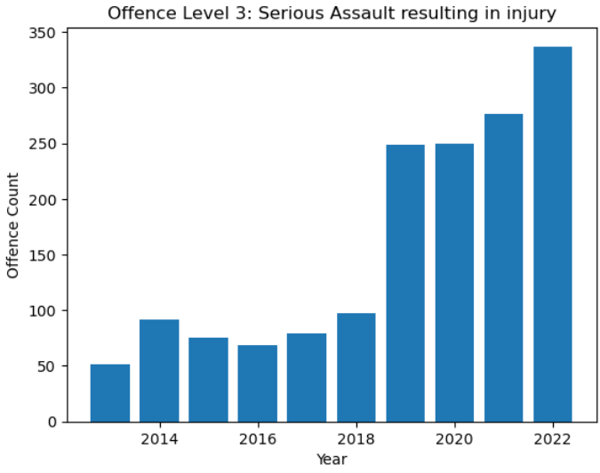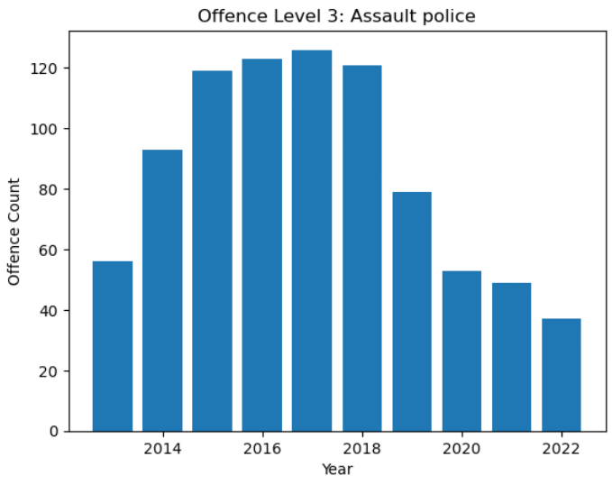

**Question 2:** Are there seasonal patterns observable in the SAPOL Data?

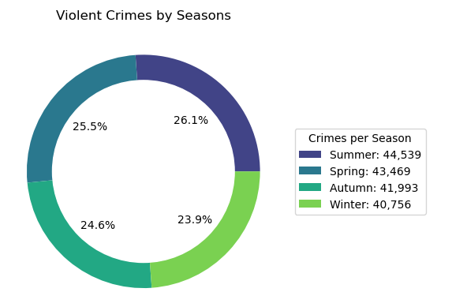

After conducting a thorough analysis of the data, it can be observed that there is a slight seasonal pattern emerging. This is best illustrated by the pie chart.

It is evident that as temperatures rise throughout the seasons, there is a corresponding increase in the occurrence of crime. However, it should be noted that the increase in crime on a season-to-season basis is relatively small.

In contrast, the increase in crime from Winter to Summer is more significant, with a total increase of approximately 9.28%. This suggests that there is a correlation between warmer temperatures and an increase in criminal activity.

**Question 3**: Has COVID had an effect on offence trends in the SAPOL Data?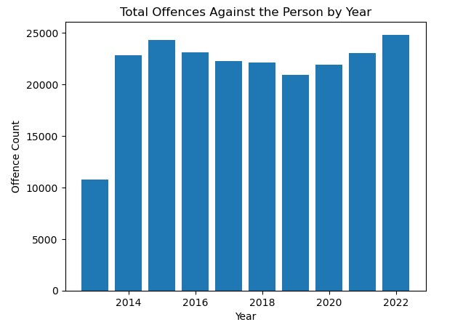

From work to play COVID 19 definitely has had an

effect on the way we live our daily lives. But has it

had an irrefutable effect on violent crime rates?

Lets look at the data and see what can be

determined.

Total Crimes Against the Person: Has this gone up since Covid? The answer is an obvious yes. Sadly it is at an all time high. But is it due to COVID? From the data in the [visualisation](https://docs.google.com/presentation/d/1KY0TsT8V26UoBkMMNvMd9bKvQMLU1e4O2NyOGjF3H68/edit?pli=1#slide=id.g24843721d3b_7_2) document we can see that the upward trend coincides on or around the pandemic and has continued on roughly the same trajectory since. You would have to argue that after several years of trending down, something happened at the end of 2019 that caused an obvious and unabated reversal of this positive trend. The obvious ‘something’ is the COVID 19 pandemic.

Violent Crime Profile: Whilst we determined that COVID was the most likely catalyst for the increase in violent crime, has it had an effect on the makeup of the violent crime profile? Using the Offence Level 2 [Visualisations](https://docs.google.com/presentation/d/1KY0TsT8V26UoBkMMNvMd9bKvQMLU1e4O2NyOGjF3H68/edit?pli=1#slide=id.g24843721d3b_7_2) year over year we notice that there was a corresponding increase in all violent crimes bar 2. The initial decrease shown of Robberies and Other Offences may have been attributed to more people staying at home making these crimes harder to perpetrate. Unfortunately this decreasing trend has not been sustained.

Furthermore looking at the makeup of the pie charts 3 years pre and 3 years post COVID we can see that Acts Intended to Cause Injury has proportionally increased the most since COVID. Now making up a larger portion of violent crimes with an average portion of 81.8%, up 4.76% post COVID. Other Offences have actually dropped considerably. This could be due to redistribution of reporting protocols from Other Offences to Acts Intended to Cause Injury, or in fact may be an accurate reflection. The other level 2 contributors to violent crimes have remained, proportionally, reasonably steady.

**Question 4**: What can we learn comparing the two highest crime areas in the SAPOL Data?

From the analysis of available data Adelaide: 23.7% Morphett Vale: 10.3%. Adelaide has a higher crime rate compared to Morphett Vale crimes reported in the dataset. This suggests that Adelaide experiences a higher number of criminal incidents within the given time period.

The higher crime count in Adelaide could indicate a higher severity or intensity of criminal activities in that suburb. This could encompass various types of crimes, ranging from offences against the person and offences against property such as theft, assault, property offences, or other offences included in the dataset.

It's important to consider the population density of each suburb. If Adelaide has a significantly larger population than Morphett Vale, the higher crime count might be influenced by a larger pool of potential perpetrators and victims. However, without population data, we cannot determine the crime rate per capita or the likelihood of an individual being affected by crime.